Exercise #8
- How many unique salary packages does our company, Bignet, Offer? List them in descending order.
SELECT DISTINCT salary FROM employee_data ORDER BY salary DESC;
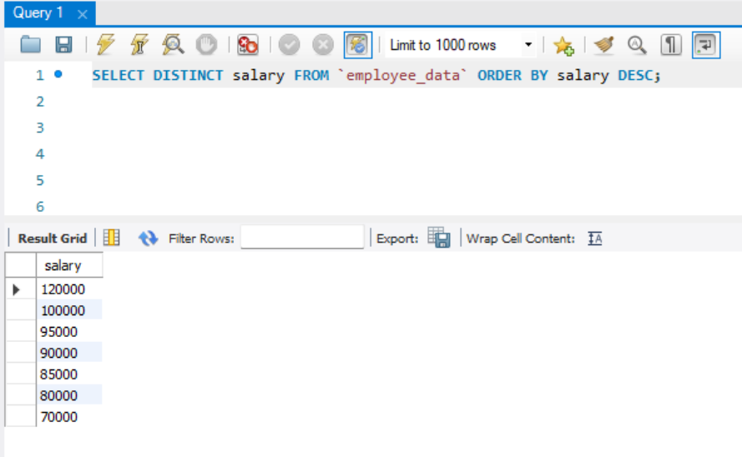
- How many District first names do we have in our database?
SELECT DISTINCT count(f_name) FROM ‘employee_data’;
